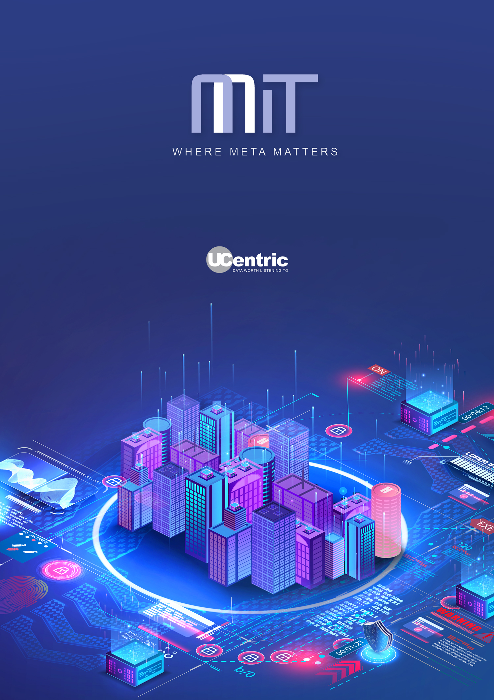

High Level Design Report

Alcatel
Introduction
This report is generated by UCentric to provide details of the existing communications infrastructure, either on-premises (PBX) or cloud-based.
As well as providing details of the existing configuration, this report will provide insights into the considerations you may need to take in account when migrating your existing solution to an alternative provider.
Whilst this report is built from your existing configuration, any such migration plan should be augmented with additional data to provide a detailed plan prior to migration. This would normally include Active Directory, Call Logging (CDR) data, Numbering plans and exports from ancillary systems such as Voice mail, IVR, Call Recorders etc.

System details
The following audit report has been automatically generated by UCentric Voice Audit from a data capture from the following communications system.

Name | Alcatel
Type | Alcatel OmniPCX
Audit date | 2023-10-17 14-30-20

Platform details

Version | Alcatel Alcatel OmniPCX
Revision | Alcatel OmniPCX
Firmware
IP Address
MAC Address

Insights summary
There is a total of 13 Directory Numbers in the existing system, including hunt groups, pickup groups and all physical extensions and profiles. In terms of numbers relating to users, they are as follows:

0 Profiles
0 Soft phones / Apps

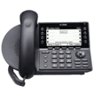
0 IP Extensions

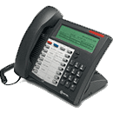
8 Digital Extensions

3 Analog Extensions

Profiles, soft phones and IP extensions are much easier to migrate than older technologies such as digital and analog phones.

Detailed Insights
This table provides a list of each type of facility that is in use across the existing solution.

Note: Not all items detailed are applicable to all vendors.

Category | Count | Information
Duplicate Extns | 0 | Usually caused by both extn and profile having same DN
Duplicate names | 0 | Will occur frequently in large organisations
Duplicate MAC addresses | 0 | Usually caused by legacy programming
Pickup groups with 1 member | 0 | Redundant programming of Pickups
Total devices | 11 | Total physical devices
Total profiles | 0 | Total profiles
Total Mobility | 0 | Total Mobility Users
Total DNs | 13 | Total DNs defined (Extns, Trunks, Groups, Digit Trans, Profiles etc.)
Total DNs without name | 0 | Total Directory Numbers without a name defined
Total without number | 0 | Total devices or profiles without a valid DN
Total Hunt Groups | 1 | Total Hunt Groups in use
Total ACD Groups | 0 | Total ACD Groups in use
Total Workgroups | 0 | Total Workgroups in use
Total Paging Groups | 0 | Total Paging Groups in use
Total Pickup Groups | 1 | Total Pickup Groups in use
Total Soft Phones | 0 | Total Soft Phones in use
Total Phantom Devices | 0 | Total Phantom Devices in use

CDR Summary
If CDR data is available, this will show a summary of call types and extension counts below

Metric | Count
Total Extension Directory Numbers (DN’s) | 11
Total Calls out for ALL DN’s | 0
Total Calls in for ALL DN’s | 0
Total number of extensions with more than 10 calls out | 0
Total number of extensions with more than 10 calls in | 0

Migration considerations to Cisco

This table will detail any common facilities being used by a legacy platform and if it is supported in the Cisco hosted and on-premise environments.

To identify parity gaps, the audit is mapped and compared to the Webex platform. There is a total of 13 directory numbers within the audited platform. Some features have a clear parity, and others will need to be reviewed prior to migration.

Facility in use | Active | Hosted HCS / On-premise CUCM | Webex Calling/ Broadworks
Digital Phones | 8 | Unsupported | Unsupported
Analog Phones | 3 | Requires cisco gateway | Requires on-premise gateway
Hunt Groups | 1 | Std feature | Std feature
Pickup Groups | 1 | Std feature | Std feature
= Supported = Unsupported = Limited support

Overall Feature Parity | Call usage (if available)
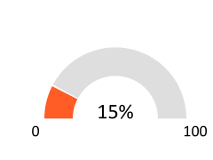 | 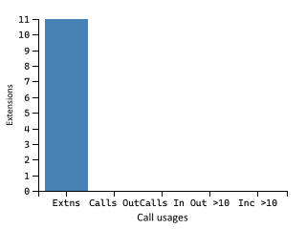

Migration considerations to Microsoft Teams

This table will detail any common facilities being used by a legacy platform and if it is supported in the Microsoft hosted environment.

To identify parity gaps, the audit is mapped and compared to the Teams platform. There is a total of 13 directory numbers within the audited platform. Some features have a clear parity, and others will need to be reviewed prior to migration.

Facility in use | Active | Teams
Digital Phones | 8 | Unsupported
Analog Phones | 3 | Requires on-premise gateway
Hunt Groups | 1 | Std feature
Pickup Groups | 1 | Std feature
= Supported = Unsupported = Limited support

Facility | # in Use | Comment
Analog Phones | 3 | Teams does not support analog devices directly. They can be connected to Teams via an on-premise SBC.

Overall Feature Parity | Call usage (if available)

Estimated Monthly Cost of E3 licenses* | Estimated Monthly Cost of E5 licenses*
£309.10 | £529.10

*Based on costs of E3 = £28.10, E3+Voice = £34.10 and E5 = £48.10

Migration considerations to RingCentral

This table will detail any common facilities being used by a legacy platform and if it is supported in the RingCentral hosted environment.

To identify parity gaps, the audit is mapped and compared to the RingCentral platform. There is a total of 13 directory numbers within the audited platform. Some features have a clear parity, and others will need to be reviewed prior to migration.

Facility in use | Active | Teams
Digital Phones | 8 | Unsupported
Analog Phones | 3 | Check models
Hunt Groups | 1 | Std feature
Pickup Groups | 1 | Std feature
= Supported = Unsupported = Limited support

Overall Feature Parity | Call usage (if available)

Migration call usage considerations
If CDR data is available, this report will detail the number of users making and receiving calls across the existing solution. This allows you to understand potential licensing costs for any cloud provider in terms of the ‘voice’ licenses and call costs.

13 Total DN's  (Directory Numbers) | 0 calls made
 | 0 incoming calls
 | 0 outgoing calls

11 users with 0 calls  0 with under 20 calls | 0 users with under 50 call involvements  0 with under 100 call involvements | 0 users with over 100 call involvements  0 over 250  0 over 1000

Energy insights

This report details potential carbon impact of the existing solution based on the following assumption: ALL devices are in use for 30% of a 5-day working week

This report is for illustration purposes only.

The current Total kWh of 0.08 can be reflected as 672.50 kW annually – This is equivalent to the following environmental impact.

352.80  Kilograms of CO₂ | 0.67  Fully grown trees felled | 0.10  Passenger cars driven for 12 months | Annual energy usage of  0.06 of a family homes
Moving to a hosted solution could potentially reduce the carbon impact of your solution by taking advantage of a multi-tenanted platform in an efficient data center.

In the meantime, you can mitigate your impact by…

Recycle 20.85 bags of waste instead of sending them to landfill
Plant 7.87 trees and let them grow for 10 years
Swapping 18.16 incandescent bulbs to LED equivalent

But you’d need to do that Every Year

Handset and Extension Summary
This details a summary of the extension types captured within the audit of the existing voice solution, and the capacity of the existing system if available.

There are 0 extension cards within the system, providing the following capacities:

 | Capacity | Used
Total | 0 | 11
Analog | 0 | 3
Digital | 0 | 8
Hybrid (i.e. COV) | 0 | 0
IP | 0 | 0

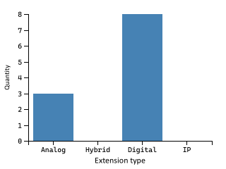

There were 0 extensions marked as ‘out of service’

There are 3 analog configured. Any migration to hosted voice that requires analog extensions (e.g. for Fax / Modems / PDQ etc.) will require FXO/Analog Gateways at the required locations.

Actual utilisation
This table shows all circuit types in use and their actual utilisation after Out-of-Service, and un-numbered extensions and trunks are removed from the programmed counts.

Circuit type | Capacity | Programmed | Out of Service | No Circuit ID | % Utilised | % Actual utilised
Extns - Analog | 3 | 3  100.00% | 0  0.00 % | 0  0% | 100.00% | 100.00%
Extns - Digital | 8 | 8  100.00% | 0  0.00 % | 0  0% | 100.00% | 100.00%

Extension Number (DN) Ranges
This details all of the extension number ranges that have been determined within the existing solution, and the number of extensions or users within each range. This is useful to determine the need for DID numbering, or to properly plan SBCs or Voice Gateway routes.

Prefix | Length | Total allocated | Start number | End number
30** | 4 | 3 | 3000 | 3002
30*** | 5 | 3 | 30030 | 30032
36* | 3 | 2 | 365 | 366
37* | 3 | 1 | 377 | 377
48* | 3 | 2 | 488 | 489

If you have extensions with different digit lengths, this can cause issues on a hosted voice solution, and should be reviewed prior to migration.

Handset Types
Where known, this details all the different handsets or softphone types in use. This allows you to understand what features and facilities users are currently utilising and ensuring that any migration does not reduce their experience.

Handset | Model | Programmed | OOS | No Extn # | Details
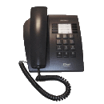 | 4004 | 6 | 0 | 0 | 8 Function keys. On hook Dialing. Message waiting light. Wall Mountable
 | Analog | 3 | 0 | 0 | Basic Analog 2-Wire/POTS Handset. No further detail available.
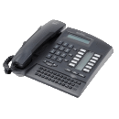 | 4020 | 2 | 0 | 0 | Multiple Line Operation, up to 12 lines. Speakerphone with digital duplex technology for sharp, clear audio, Built-In Caller ID, LCD Display, Intercom function, Digital Phone for integration with PC systems. Integrated keyboard allows for the dial-by-name feature as well as text messaging.

License usage
There are several ways in which licenses are detailed within voice platforms, this section will detail the licenses on the PBX/Voice Platform

Note: Licensing isn’t always available.

License type | Name | ID | Fixed Value | Maximum | Used | Available | % Used

Call forwarding and Speed-dials.
This shows all call forwards, except where the device is only forwarded to voicemail (in order to reduce the size of this list)

If you have extensions call forwarded to external numbers – these should be reviewed prior to any migration as many diverts can be handled within call plans instead of diverting over the PSTN.

Total extensions forwarded to external numbers: 0
Total extensions forwarded to internal numbers: 0

Extension | Busy Int | Busy Ext | No Answer Int | No Answer Ext | Always | Voicemail
None captured

Forwards to Speed-dials
Call forwarding to speed-dials can obscure real destinations of call forwarding – numbers above shown in purple are the speed-dial number and the actual destination is show in red.

Extn | Name | Busy Int | Busy Ext | No Answer Int | No Answer Ext | Always

System Speed-dials
Speed dials or system short-codes are used to ease frequent dialling of external numbers.

Note: They are often used to route calls between local PABXs and allow toll-overrides to occur, so should always be reviewed as it could highlight costly routing or where calls are being diverted to satellite offices or home-workers. If home-workers are using diverted numbers, this is an opportunity to use soft-clients and avoid unnecessary toll costs.

Speed-dial code | Actual number | Type | Name

COS and COR Usage Summary

The following Class of Service (COS) and Class of Restrictions (COR) entries were discovered during the audit. This allows you to create a standard facilities and dial plan for your users when migrating to a hosted solution.

These existing restrictions can be used to map features and permissions on a cloud solution, and the UCentric LLD plan allows this to be assigned automatically.

COS / COR | Total DN’s | % using | Device type | COS / COR descriptions | Information
4 / 0 | 6 | 54.55 | Digital
8 / 3 | 2 | 18.18 | Analog
2 / 0 | 1 | 9.09 | Digital
6 / 1 | 1 | 9.09 | Digital
7 / 3 | 1 | 9.09 | Analog

Details of where there are less than 20 DN’s (of the same device type) using a COS / COR combination. This allows you to see where there are special cases in terms of restrictions that may need to be considered when migrating to a hosted solution.

COS / COR | DN | Name | Detail | COS / COR descriptions | Device type
7 / 3 | 365 | BST 0347 Albus Dumbledore | Analog |  | Analog
6 / 1 | 366 | BST 0347 Rubeus Hagrid | 4020 |  | Digital
4 / 0 | 377 | BST 0347 Harry Potter | 4004 |  | Digital
4 / 0 | 3000 | BST 0347 Fred Bloggs | 4004 |  | Digital
4 / 0 | 3001 | BST 0347 Forèign Bôb O’Reilly | 4004 |  | Digital
4 / 0 | 3002 | BST 0347 Luke Skywalker | 4004 |  | Digital
2 / 0 | 30030 | BST 0347 Marty McFly | 4020 |  | Digital
4 / 0 | 30031 | BST 0347 Basic Phone | 4004 |  | Digital
4 / 0 | 30032 | BST 0347 Fax Phone | 4004 |  | Digital
8 / 3 | 488 | BST 0347 Virtual User One | Analog |  | Analog
8 / 3 | 489 | BST 0347 Virtual User Two | Analog |  | Analog

Call Flows, Routing and Groups

Hunt, Pickup and ACD Groups
Hunt groups and pickup groups operate in two different ways; Hunt and ACD groups will find the first available member (based on rules applied), whereas Pickup groups ring all members at the same time.

Category | Pilot Number | Name | # of Members | Warning
Hunt | 6034710 | Hunt 6034710 | 4
Pickup | BST 0347 | Pickup BST 0347 | 8

Groups with a single member
Category | Name | Type | Member DN | Member Name

- Note: Pickup groups with a single member are redundant – Hunt groups with a single member may be used for diverting non-geographic or other external numbers and should be reviewed.

Call flows
This chart details call flows that involve DDI to groups or IVR / Auto-attendants.

Call flows will also show on the LLD only if the system contains IVR, AA or External Hunt Groups.

Trunks
The trunk information isn’t directly necessary in order to migrate to cloud solutions but is a useful metric in order to determine existing usage and capacities.

There are 0 trunk cards within the system, providing the following capacities:

 | Capacity | Used
Total | 0 | 0
Analog | 0 | 0
Digital | 0 | 0
Hybrid (i.e. AC13/AC15/E&M) | 0 | 0
IP | 0 | 0
AC13 | 0
AC15 | 0
E&M | 0

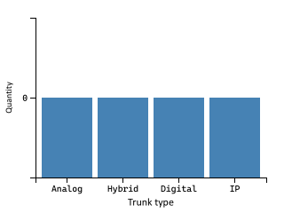
There were 0 trunks marked as ‘out of service’

There are 0 digital trunks configured. As of 2025, BT will no longer support ISDN.

Trunk groups
Where trunk information is captured, this details the trunk groups and types that are configured on the existing solution.

Trunk Group | # of Members | Description | Group type

Out of service
This shows the total of all “Out of Service” devices. This is determined as: Analog Extensions/Trunks that have been marked “OOS” by an Engineer; Digital Extensions/Trunks that have been marked “OOS” by either the PABX or an Engineer (e.g. If a digital set is unplugged, it is usually marked “OOS” by the PABX automatically).

Type | Sub-type | State | Total OOS | Resilient | Actual OOS
None found

Note: If hotdesking is in use, any devices or profiles currently logged out may show as “Out of service” depending on the existing vendor platform.

Region information
Many systems provide a centralised call-control, with gateways to extend that service to remote offices. Detailed below is a summary of any regional or remote users discovered.

Region ID | Region Name | Standard Sets | IP Sets
None found

Extension ranges by location
Much like the previous list of extension ranges, this shows which extension numbers are being used, but in this case, broken down by region or location.

Region | Extn prefix | Total # in range | Range start | Range end
 | 30** | 3 | 3000 | 3002
 | 30*** | 3 | 30030 | 30032
 | 36* | 2 | 365 | 366
 | 48* | 2 | 488 | 489
 | 37* | 1 | 377 | 377

Glossary of terms
Term | Definition
ACD group | Automatic Call Distribution – a type of hunt group that can route calls based on rules (e.g. Longest ringing, Skills, calling-line ID etc.)
Analog Adapter | An Analog Telephone Adapter device (e.g. connector to Fax, Intercom, Alarm, etc.) – Sometimes called an FXO/FSX adapter
Analog Phone | An Analog Telephone device that is connected to a remote gateway (e.g. connector to Fax, Intercom, PDQ, Alarm, etc.).
Audio Conference Phone | An Audio Conference desk phone device.
Common Area Phone  (CAP) | A device that is not associated with a user. Also referred to as Standalone Device or Utility Phone
CTI | Computer Telephony Integration (CTI) enables users to take advantage of  computer-processing functions while making, receiving, and managing telephone calls. CTI applications allow you to perform such tasks as retrieving customer information from a database using a caller ID, or to work with the information gathered by an Interactive Voice Response (IVR) system to route a customer’s call, along with their information, to the appropriate customer service representative.
Device Profile | A device profile comprises the set of attributes (services and/or features), e.g. line number, forwarding, that will appear on the phone when the associated user logs in.
Devices | Hardware or software telephony clients configured in the legacy PBX. Devices can  be associated to one or multiple extensions.
Feature Parity | This shows if particular features can translate easily to an alternative provider
FXO / FXS | Foreign Exchange Subscriber/Office – This is an analog line or port that a phone or fax machine connects to. It is a common description for Analog ports on a Cisco CUCM/CME
Hunt Group | A Hunt Group is the method of distributing phone calls from a single telephone  number to a group of several phone extensions.
IP Phone | A desktop phone also referred to as a handset device.
Legacy PABX/PBC | The telephony system which is being assessed and reported in this document.
Line | A telephone number configured on the legacy PBX.
Orphaned Cisco End-User | An end-user that is not associated with any device or device profile.
On-Prem | Another definition for locally hosted voice (as opposed to ‘Cloud’ hosted)
Partial Feature Parity | This indicates that the feature is currently not fully supported by Microsoft Teams.  Users configured with this feature can be migrated but might lose some  functionality. In some cases, 3rd party solutions can close the gap.
Pickup Group | Group of users authorized to answer calls to a telephone extension within that  group of users.
Software Client | An Android / iOS / PC Software client device.
Standalone Device | A device that is not associated with a user. Also referred to as Common Area Phone in Microsoft Teams.
Telepresence | An Advanced Video Conferencing device.
Users | End users that are configured on the legacy PBX. Users can be associated to  multiple devices and device profiles.
Video Phone | A handset device with video capabilities.
Wireless IP Phone | A wireless handset device.

