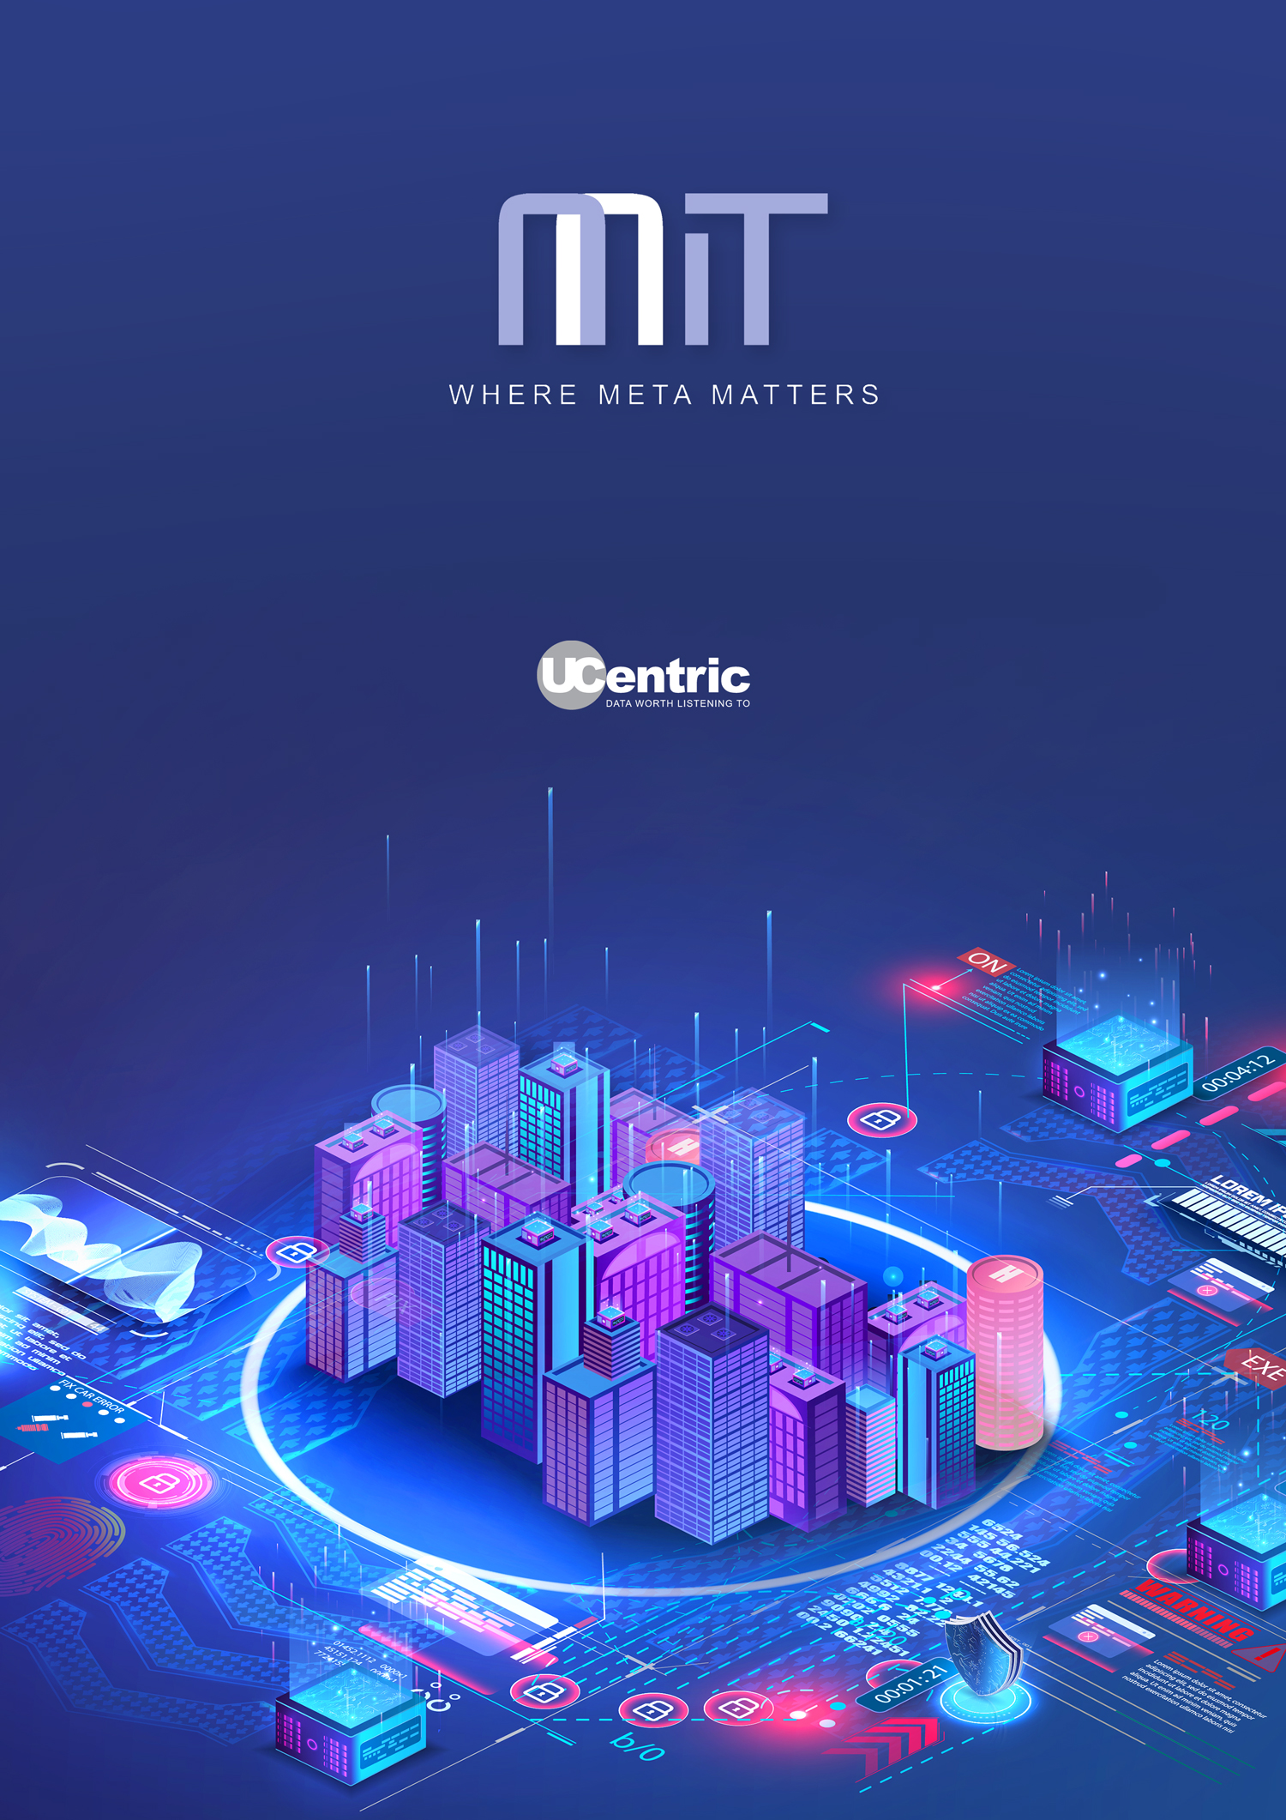

High Level Design Report

Cisco
Introduction
This report is generated by UCentric to provide details of the existing communications infrastructure, either on-premises (PBX) or cloud-based.
As well as providing details of the existing configuration, this report will provide insights into the considerations you may need to take in account when migrating your existing solution to an alternative provider.
Whilst this report is built from your existing configuration, any such migration plan should be augmented with additional data to provide a detailed plan prior to migration. This would normally include Active Directory, Call Logging (CDR) data, Numbering plans and exports from ancillary systems such as Voice mail, IVR, Call Recorders etc.

System details
The following audit report has been automatically generated by UCentric Voice Audit from a data capture from the following communications system.

Name | Cisco
Type | Cisco CUCM
Audit date | 2023-10-17 14-34-19

Platform details

Version | Cisco CUCM
Revision | 12.5.1.16900-48.i386
Firmware
IP Address | 192.168.1.140
MAC Address

Please note, this is an audit of a single or standalone PBX.
Some tables or columns may be empty in this report. This is to be expected due to the flexibility available in system programming. It indicates that no data was found within the system for that table or column.

Cisco (Legacy) Licenses
Some legacy CUCM and CME platforms control licensing of devices locally. Where this is the case, this will be shown here.

Description | Distributed | Used | Pending
None found

Insights summary
There is a total of 12 Directory Numbers in the existing system, including hunt groups, pickup groups and all physical extensions and profiles. In terms of numbers relating to users, they are as follows:

7 Profiles of which 7 are defined as ‘Home Cluster’

2 Soft phones / Apps

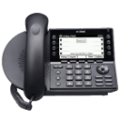
7 IP Extensions

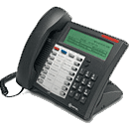
0 Digital Extensions

2 Analog Extensions

Profiles, soft phones and IP extensions are much easier to migrate than older technologies such as digital and analog phones.

Detailed Insights
This table provides a list of each type of facility that is in use across the existing solution.

Note: Not all items detailed are applicable to all vendors.

Category | Count | Information
Duplicate Extns | 0 | Usually caused by both extn and profile having same DN
Duplicate names | 0 | Will occur frequently in large organisations
Duplicate MAC addresses | 0 | Usually caused by legacy programming
Pickup groups with 1 member | 1 | Redundant programming of Pickups
Total devices | 2 | Total physical devices
Total profiles | 7 | Total profiles
Total Home Cluster profiles | 7 | Total profiles marked as `Home Cluster`
Total Non-Home Cluster profiles | 0 | Total profiles that are not marked as `Home Cluster`
CSF devices | 2 | Total number of devices using `Cisco Client Services Framework`
IP Communicators | 1 | Total number of `IP Communicators`
Total Mobility | 0 | Total Mobility Users
Total DNs | 12 | Total DNs defined (Extns, Trunks, Groups, Digit Trans, Profiles etc.)
Total DNs without name | 0 | Total Directory Numbers without a name defined
Total without number | 0 | Total devices or profiles without a valid DN
Total Hunt Groups | 2 | Total Hunt Groups in use
Total Workgroups | 0 | Total Workgroups in use
Total Paging Groups | 0 | Total Paging Groups in use
Total Pickup Groups | 1 | Total Pickup Groups in use
Total Soft Phones | 2 | Total Soft Phones in use

CDR Summary
If CDR data is available, this will show a summary of call types and extension counts below.

Metric | Count
Total Extension Directory Numbers (DN’s) | 9
Total Calls out for ALL DN’s | 0
Total Calls in for ALL DN’s | 0
Total number of extensions with more than 10 calls out | 0
Total number of extensions with more than 10 calls in | 0

Migration considerations to Cisco

This table will detail any common facilities being used by a legacy platform and if it is supported in the Cisco hosted and on-premise environments.

In order to identify parity gaps, the audit is mapped and compared to the Webex platform. There is a total of 12 directory numbers within the audited platform. Some features have a clear parity, and others will need to be reviewed prior to migration.

Facility in use | Active | Hosted HCS / On-premise CUCM | Webex Calling/ Broadworks
Call Forwarding | 7 | Std feature | Std feature
Cisco Phones | 7 | Std feature | Std feature
Total profiles | 7 | Std feature | Std feature
Analog Phones | 2 | Requires cisco gateway | Requires on-premise gateway
Hunt Groups | 2 | Std feature | Std feature
Pickup Groups | 1 | Std feature | Std feature
= Supported = Unsupported = Limited support

Overall Feature Parity | Call usage (if available)
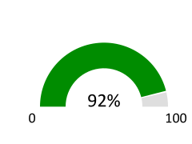 | 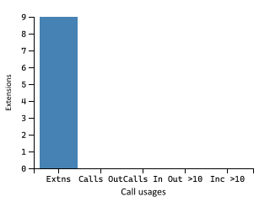

Migration considerations to Microsoft Teams

This table will detail any common facilities being used by a legacy platform and if it is supported in the Microsoft hosted environment. In order to identify parity gaps, the audit is mapped and compared to the Teams platform. There is a total of 12 directory numbers within the audited platform. Some features have a clear parity, and others will need to be reviewed prior to migration.

Facility in use | Active | Teams
Call Forwarding | 7 | Std feature
Cisco Phones | 7 | Unsupported
Total profiles | 7 | Std feature
Analog Phones | 2 | Requires on-premise gateway
Hunt Groups | 2 | Std feature
Pickup Groups | 1 | Std feature
= Supported = Unsupported = Limited support

Facility | # in Use | Comment
Analog Phones | 2 | Teams does not support analog devices directly. They can be connected to Teams via an on-premise SBC.
Call forwards to external numbers | 1 | Call forward external not supported by Teams

Overall Feature Parity | Call usage (if available)
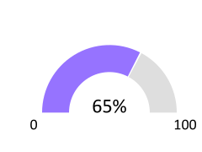

Estimated Monthly Cost of E3 licenses* | Estimated Monthly Cost of E5 licenses*
£252.90 | £432.90
*Based on costs of E3 = £28.10, E3+Voice = £34.10 and E5 = £48.10

Migration considerations to RingCentral

This table will detail any common facilities being used by a legacy platform and if it is supported in the RingCentral hosted environment.

In order to identify parity gaps, the audit is mapped and compared to the RingCentral platform. There is a total of 12 directory numbers within the audited platform. Some features have a clear parity, and others will need to be reviewed prior to migration.

Facility in use | Active | Teams
Call Forwarding | 7 | Std feature
Cisco Phones | 7 | Check Models
Total profiles | 7 | Std feature
Analog Phones | 2 | Check models
Hunt Groups | 2 | Std feature
Pickup Groups | 1 | Std feature
= Supported = Unsupported = Limited support

Overall Feature Parity | Call usage (if available)

Migration call usage considerations
If CDR data is available, this report will detail the number of users making and receiving calls across the existing solution. This allows you to understand potential licensing costs for any cloud provider in terms of the ‘voice’ licenses and call costs.

12 Total DN's  (Directory Numbers) | 0 calls made
 | 0 incoming calls
 | 0 outgoing calls

9 users with 0 calls  0 with under 20 calls | 0 users with under 50 call involvements  0 with under 100 call involvements | 0 users with over 100 call involvements  0 over 250  0 over 1000

Energy insights
This report details potential carbon impact of the existing solution based on the following assumption: ALL devices are in use for 30% of a 5-day working week

This report is for illustration purposes only.

The current Total kWh of 0.14 can be reflected as 1267.29 kW annually

664.84  Kilograms of CO₂ | £ 481.57  Per annum in energy costs

This is equivalent to the following environmental impact.

1.27  Fully grown trees felled | 0.19  Passenger cars driven for 12 months | Annual energy usage of  0.10 of a family homes
Moving to a hosted solution could potentially reduce the carbon impact of your solution by taking advantage of a multi-tenanted platform in an efficient data center.

In the meantime, you can mitigate your impact by…

Recycle 39.29 bags of waste instead of sending them to landfill
Plant 14.83 trees and let them grow for 10 years
Swapping 34.22 incandescent bulbs to LED equivalent

But you’d need to do that Every Year

Gateway / Cabinet overview
There are 1 Gateways/Cabinets in this configuration.

Gateway name | Detail | MAC | IP Address
System
-

SRST Servers
Survivable Remote Site Telephony (SRST) is a Cisco Unified Communications Manager (CUCM) call processing backup mechanism that allows Cisco IP phones to register to a Cisco router and provide local communications in the event of connection to the main CUCM being inaccessible.

SRST | IP Address 1 | Port 1 | IP Address 2 | Port 2 | IP Address 3 | Port 3
Disable |  | 2000 |  | 2000 |  | 2000
Use Default Gateway |  | 2000 |  | 2000 |  | 2000

Handset and Extension Summary
This details a summary of the extension types captured within the audit of the existing voice solution, and the capacity of the existing system if available.

 | Used
Total | 9
Analog | 2
Digital | 0
Hybrid (i.e. COV) | 0
IP | 7

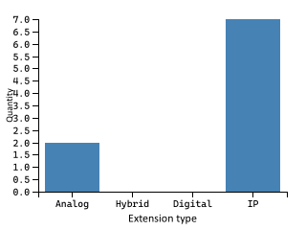

There were 0 extensions marked as ‘out of service’

There are 2 analog devices configured. Any migration to hosted voice that requires analog extensions (e.g. for Fax / Modems / PDQ etc.) will require FXO/Analog Gateways at the required locations.

Extension Number (DN) Ranges
This details the extension number ranges that have been determined within the existing solution, and the number of extensions or users within each range. This is useful to determine the need for DID numbering, or to properly plan SBCs or Voice Gateway routes.

Prefix | Length | Total allocated | Start number | End number
30** | 4 | 3 | 3000 | 3002
30*** | 5 | 3 | 30030 | 30032
36* | 3 | 2 | 365 | 366
37* | 3 | 1 | 377 | 377

If you have extensions with different digit lengths, this can cause issues on a hosted voice solution, and should be reviewed prior to migration.

Handset Types
Where known, this details all the different handsets or softphone types in use. This allows you to understand what features and facilities users are currently utilising and ensuring that any migration does not reduce their experience.

Handset | Model | Programmed | OOS | No Extn # | Details
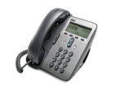 | Cisco 7911 | 2 | 0 | 0 | Cisco IP Phone 7911 with 4 dynamic soft keys. PoE support, SIP ready, integrated 10/100 switch.
 | Cisco Unified Client Services Framework | 2 | 0 | 0 | Phone Cisco Unified Client Services Framework for unified soft clients
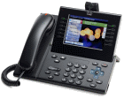 | Cisco 9951 | 1 | 0 | 0 | Cisco Unified IP Phone 9951 is an advanced collaborative media endpoint that provides voice, video, applications, and accessories. Gigabit Ethernet and a new ergonomic design and user interface designed for simplicity and high usability.
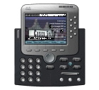 | Cisco IP Communicator | 1 | 0 | 0 | Cisco IP Communicator software-based PC app for use as a telecommuting device, or as a primary desktop telephone.
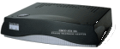 | Cisco ATA 186 | 1 | 0 | 0 | Cisco ATA 186 analog phone adapter for routing IP to analog devices in the network.
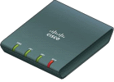 | Cisco ATA 187 | 1 | 0 | 0 | Analog Telephone Adaptor - VoIP phone adapter - Ethernet, Fast Ethernet - external analog Telephone Adaptor is a handset-to-Ethernet adaptor.
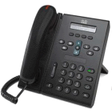 | Cisco 6921 | 1 | 0 | 0 | Cisco Unified IP Phone 6921 with 2 lines and offers a full-duplex speakerphone and a single-call per-line appearance. Fixed keys for hold, transfer, and conference.

Unsupported Cisco phones
This is used only when migrating to hosted Cisco solutions (i.e. Webex Calling, BT OCC or Vodafone VONE-C)

Location | Model | DN | IP | MAC
None found

Call forwarding
This shows all call forwards, except where the device is only forwarded to voicemail (in order to reduce the size of this list)

If you have extensions call forwarded to external numbers – these should be reviewed prior to any migration as many diverts can be handled within call plans instead of diverting over the PSTN.

Total extensions forwarded to external numbers: 1
Total extensions forwarded to internal numbers: 7

Extension | Busy Int | Busy Ext | No Answer Int | No Answer Ext | Always
3000 | 3001 | 3001 | 3001 | 3001
3001 |  |  |  |  | 3002
3002 |  |  |  | 30031
30030 |  |  |  |  | 30032
30031 |  |  | 5000 | 5000
30032 |  |  | 5000 | 5000
365 | 30020 | 30020 | 447967033598 | 447967033598

Calling Search Space
A calling search space comprises an ordered list of partitions that users can look at before users are allowed to place a call. Calling search spaces determine the partitions that calling devices, including IP phones, soft phones, and gateways, can search when attempting to complete a call.

These existing restrictions can be used to map features and permissions on a cloud solution, and the UCentric LLD plan allows this to be assigned automatically.

Name | Description | Calling Search Spaces
None found

Trunks
The trunk information isn’t directly necessary in order to migrate to cloud solutions, but is a useful metric in order to determine existing usage and capacities.

Trunk Group | Device Pool | Description | CSS | Group type

Type | Total allocated
Analog | 0
Digital | 0
Hybrid (i.e. AC13/AC15/E&M) | 0
IP | 0

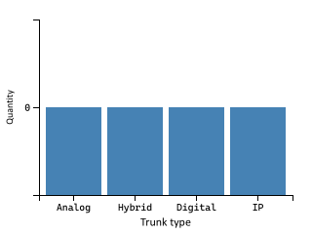

There are 0 digital trunks configured. As of 2025, BT will no longer support ISDN.

Call Flows, Routing, and Groups
Hunt groups and pickup groups operate in two different ways; Hunt and ACD groups will find the first available member (based on rules applied), whereas Pickup groups ring all members at the same time.

Category | Pilot Number | Name | # of Members | Warning
Hunt | 567 |  | 3
Hunt | 569 | Hunt Group 1 | 3
Pickup | 4002 | Pickup Group 1 | 1 | Single member of group

Groups with a single member
Category | Name | Type | Member DN | Member Name
4002 | Pickup Group 1 | Pickup | 30031 | Basic Phone

Note: Pickup groups with a single member are redundant – Hunt groups with a single member may be used for diverting non-geographic or other external numbers and should be reviewed.

Translation Patterns
Cisco CUCM uses translation patterns to manipulate digits before forwarding calls across the voice network. A translation pattern normally requires another digit analysis attempt. Translation patterns and route patterns can be used to block patterns, but the default action is to attempt call routing.

Pattern | Description | CSS | Route Partition | Called Party Transform Mask | Called Party Prefix

Call flows
This chart details call flows that involve DDI to groups or IVR / Auto-attendants.

Call flows will appear here and in the LLD if the system contains IVR, AA or external hunt groups.

Route Lists
The table below shows Route Lists that are associated with a Call Manager group and Route Groups

Route | Type | Call Manager Group | Route Group

Location information
Many systems provide a centralised call-control, with gateways to extend that service to remote offices. Detailed below is a summary of any location or remote users discovered.

Region ID | Region Name | Standard Sets | IP Sets
0 | Default | 0 | 7
1 | US Site SLC | 0 | 0
2 | United Kingdom | 0 | 0
3 | US Site | 2 | 0
4 | Phantom | 0 | 0
5 | Shadow | 0 | 0

Extension ranges by location
Much like the previous list of extension ranges, this shows which extension numbers are being used, but in this case, broken down by region or location.

Region | Extn prefix | Total # in range | Range start | Range end
Default | 30** | 3 | 3000 | 3002
Default | 36* | 2 | 365 | 366
Default | 37* | 1 | 377 | 377
Default | 30*** | 1 | 30030 | 30030
US Site | 30*** | 2 | 30031 | 30032

Glossary of terms
Term | Definition
ACD group | Automatic Call Distribution – a type of hunt group that can route calls based on rules (e.g. Longest ringing, Skills, calling-line ID etc.)
Analog Adapter | An Analog Telephone Adapter device (e.g. connector to Fax, Intercom, Alarm, etc.) – Sometimes called an FXO/FSX adapter
Analog Phone | An Analog Telephone device that is connected to a remote gateway (e.g. connector  to Fax, Intercom, PDQ, Alarm, etc.).
Audio Conference Phone | An Audio Conference desk phone device.
Common Area Phone  (CAP) | A device that is not associated with a user. Also referred to as Standalone Device or  Utility Phone
CTI | Computer Telephony Integration (CTI) enables users to take advantage of  computer-processing functions while making, receiving, and managing telephone  calls. CTI applications allow you to perform such tasks as retrieving customer  information from a database using a caller ID, or to work with the information  gathered by an Interactive Voice Response (IVR) system to route a customer’s call,  along with their information, to the appropriate customer service representative.
Device Profile | A device profile comprises the set of attributes (services and/or features), e.g. line  number, forwarding, that will appear on the phone when the associated user logs  in.
Devices | Hardware or software telephony clients configured in the legacy PBX. Devices can  be associated to one or multiple extensions.
Feature Parity | This shows if particular features can translate easily to an alternative provider
FXO / FXS | Foreign Exchange Subscriber/Office – This is an analog line or port that a phone or fax machine connects to. It is a common description for Analog ports on a Cisco CUCM/CME
Hunt Group | A Hunt Group is the method of distributing phone calls from a single telephone  number to a group of several phone extensions.
IP Phone | A desktop phone also referred to as a handset device.
Legacy PABX/PBC | The telephony system which is being assessed and reported in this document.
Line | A telephone number configured on the legacy PBX.
Orphaned Cisco End-User | An end-user that is not associated with any device or device profile.
On-Prem | Another definition for locally hosted voice (as opposed to ‘Cloud’ hosted)
Partial Feature Parity | This indicates that the feature is currently not fully supported by Microsoft Teams.  Users configured with this feature can be migrated but might lose some  functionality. In some cases, 3rd party solutions can close the gap.
Pickup Group | Group of users authorized to answer calls to a telephone extension within that  group of users.
Software Client | An Android / iOS / PC Software client device.
Standalone Device | A device that is not associated with a user. Also referred to as Common Area Phone  in Microsoft Teams.
Telepresence | An Advanced Video Conferencing device.
Users | End users that are configured on the legacy PBX. Users can be associated to  multiple devices and device profiles.
Video Phone | A handset device with video capabilities.
Wireless IP Phone | A wireless handset device.

